

Ensemble Learning to predict air quality: A comparative analysis

A Thesis Submitted in Partial
fulfillment for the requirement of the
Degree of

Bachelor of Science
in
Computer Science and Engineering

by

Zakia Sultana Bhuiyan
Roll No. 213071015

to the

Department of Computer Science and Engineering
Shanto-Mariam University of Creative Technology

November, 2025

Acknowledgement

This thesis has been submitted to the Department of Computer Science and Engineering of Shanto-Mariam University of Creative Technology (SMUCT), Dhaka, Bangladesh, for the partial fulfillment of the requirements for the degree of B.Sc. in Computer Science and Engineering. Thesis title regards to "ENSEMBLE LEARNING TO PREDICT AIR QUALITY: A COMPARATIVE ANALYSIS".

First and foremost, I offer my sincere gratitude and indebtedness to my thesis supervisor, Shakkhor Das, Lecturer, Department of Computer Science and Engineering who has supported me throughout my thesis with his patience and knowledge. I shall ever remain grateful to him for his valuable guidance, advice, encouragement, cordial and amiable contribution to my thesis.

I wish to thank Mr. Faisal Imran as the head of the Department of Computer Science and Engineering for his support and encouragement and also for providing all kind of laboratory facilities.

I would like to express my deep gratitude to my family. They have always encouraged me during the research. I am also grateful to the administration of Shanto-Mariam University of Creative Technology for providing a self-sufficient Under Graduate (UG) lab.

Finally, I want to thank the most important and closest persons in my life, my sister and my parents for giving a lot of support to me.

Zakia Sultana Bhuiyan  Roll No. 213071015 | November, 2025  SMUCT, Dhaka, Bangladesh

CERTIFICATE

This is to certify that the thesis entitled "ENSEMBLE LEARNING TO PREDICT AIR QUALITY: A COMPARATIVE ANALYSIS" by Zakia Sultana Bhuiyan, (Roll No. 213071015), has been carried out under my direct supervision. To the best of my knowledge, this thesis is an original one and has not been submitted anywhere for any degree or diploma.

Thesis Supervisor:

.......................................
Mr. Shakkhor Das
Lecturer
Department of Computer Science and Engineering
Shanto-Mariam University of Creative Technology

CERTIFICATE

This is to certify that the thesis entitled "ENSEMBLE LEARNING TO PREDICT AIR QUALITY: A COMPARATIVE ANALYSIS" has been corrected according to my suggestion and guidance as an external. The quality of the thesis is satisfactory.

External Member:

.......................................
Mr. Shakkhor Das
Lecturer
Department of Computer Science and Engineering
Shanto-Mariam University of Creative Technology

CERTIFICATE

This is to certify that the thesis entitled "ENSEMBLE LEARNING TO PREDICT AIR QUALITY: A COMPARATIVE ANALYSIS" by Zakia Sultana Bhuiyan(ID: 213071015) has been carried out under the direct supervision of Shakkhor Das. This thesis has been carried out according to the Department of Computer Science & Engineering of Shanto-Mariam University of Creative Technology guidelines.

Head of The Department

………………………………..
Mr. Faisal Imran
Head (In-Charge),
Department of Computer Science & Engineering

Declaration

I the undersigned member of this thesis, hereby declare that the thesis titled “ENSEMBLE LEARNING TO PREDICT AIR QUALITY: A COMPARATIVE ANALYSIS” represents my original work conducted under the supervision of Sakhor Das Opi at Shanto-Mariam University of Creative Technology (SMUCT) Dhaka, Bangladesh. All the information, data and findings presented in this thesis are genuine and have not been submitted elsewhere for any other degree or diploma.

I further declare that any external sources, references, or materials used in this research have been duly cited in accordance with the academic standards and guidelines.

I understand the consequences of academic dishonesty and collectively affirm that this thesis represents our joint efforts and understanding of the subject matter.

Signatures:

__________________________
Zakia Sultana Bhuiyan
ID No: 213071015
Department of Computer Science and Information Technology
Shanto-Mariam University of Creative Technology

Abstract
Air pollution has become one of the most significant challenges in modern urban life, directly affecting human health and the environment.
The Air Quality Index (AQI) is a key measure used to determine pollution levels and to inform public safety.
This research focuses on predicting air quality using ensemble machine learning models by comparing different algorithms for both classification and regression tasks.
A complete predictive pipeline was developed using Python, where traditional machine learning models such as Logistic Regression, Decision Tree, Random Forest, SVM, LightGBM, XGBoost, and CatBoost were tested for classification, while models like Linear Regression, Random Forest Regressor, LSTM, ARIMA, BP Neural Network, CatBoost Regressor, and XGBoost Regressor were applied for regression.
In addition, two ensemble strategies — Weighted Ensemble and Stacking Ensemble — were implemented to improve overall prediction accuracy.
The study demonstrated that the LightGBM classifier achieved the highest accuracy for AQI category classification, while the Stacking Ensemble Regression model provided the best R² score in predicting actual AQI values.
This work highlights the potential of ensemble learning in improving air quality forecasting systems and provides a foundation for future environmental data analytics.

Contents

Acknowledgement |  |  |  | ii
Certificate |  |  |  | iii-iv
Declaration |  |  |  | v
Abstract |  |  |  | vi
List of Figures |  |  |  | xi
List of Tables |  |  |  | xii
List of Abbreviations |  |  |  | xiii
List of Symbols |  |  |  | xiv
1 | Introduction |  |  | 15
 | 1.1 | Background |  | 15
 | 1.2 | Problem Statement |  | 15
 | 1.3 | Research Questions |  | 16
 | 1.4 | Objectives |  | 16
 | 1.5 | Significance of the Study |  | 16
 | 1.6 | Thesis Structure |  | 16
2 | Literature Review |  |  | 18
 | 2.1 | Introduction to Air Pollution and AQI Research |  | 18
 | 2.2 | Traditional Statistical Methods for AQI Prediction |  | 18
 | 2.3 | Machine Learning Models for AQI Forecasting |  | 19
 | 2.4 | Deep Learning Approaches |  | 20
 | 2.5 | Ensemble Learning Approaches |  | 20
 | 2.6 | Meteorological Influence on AQI |  | 21
 | 2.7 | Limitations of Existing Studies |  | 21
 | 2.8 | Summary of Literature Review |  | 22
3 | Methodology |  |  | 23
 | 3.1 | Overview of the Research Framework |  | 23
 | 3.2 | Dataset Description |  | 24
 | 3.3 | Data Preprocessing:  3.3.1 Date Parsing and Sorting  3.3.2 Handling Missing and Invalid Values  3.3.3 Removing Rare Categories  3.3.4 Normalization of Numerical Features  3.3.5 Encoding AQI Class Labels |  | 25-27
 | 3.4 | Feature Engineering:  3.4.1 Time Derived Features  3.4.2 Lag Features  3.4.3 Rolling Window Features  3.4.4 Final Feature Space |  | 27-28
 | 3.5 | Model Selection Strategy |  | 29
 | 3.6 | Classification Methodology:  3.6.1 Classification workflow  3.6.2 Train-Test Split  3.6.3 Cross - Validation  3.6.4 Hyperparameter Tuning (Boosting Models)  3.6.5 Weighted Classifier  3.6.6 Stacking Classifier |  | 30-31
 | 3.7 | Regression Methodology  3.7.1 Regression Workflow  3.7.2 Train-Test Split  3.7.3 Regression Models  3.7.4 Stacking Regressor |  | 32-33
 | 3.8 | Evaluation Metrics |  | 33
 | 3.9 | Visualization & Reporting |  | 33
 | 3.10 | Summary of Methodology |  | 34
4 | Model Implementation |  |  | 35
 | 4.1 | Environment Setup |  | 35
 | 4.2 | Data Loading and Initial Configuration |  | 35
 | 4.3 | Feature Engineering Implementation:  4.3.1 Temporal Features  4.3.2 Lag Features  4.3.3 Rolling Window Features |  | 36
 | 4.4 | Classification: Model Implementation  4.4.1 Data Preparation for Classification  4.4.2 Base Classification Models Implemented  4.4.3 Tuned Boosting Models  4.4.4 Weighted Classifier (RF + SVM)  4.4.5 Stacking Classifier  4.4.6 Classification Evaluation & Visualization |  | 37-41
 | 4.5 | Regression: Model Implementation  4.5.1 Data Preparation  4.5.2 Base Regression Models  4.5.3 BP Neural Network (Deep Learning Model)  4.5.4 Stacking Regressor |  | 41-43
5 | Results and Discussion |  |  | 44
 | 5.1 | Overview of Evaluation Strategy |  | 44
 | 5.2 | Classification Results  5.2.1 Confusion Matrics  5.2.2 Classification Matrics Summary  5.2.3 Discussion of Classification Performance |  | 45-47
 | 5.3 | Regression Result  5.3.1 Predict vs Actual ScatterPlots  5.3.2 Regression Metrics Summary  5.3.3 Discussion of Regression Performance |  | 47-49
 | 5.4 | Comparative Insights |  | 50
 | 5.5 | Error Analysis |  | 50
 | 5.6 | Relationship to Literature |  | 51
 | 5.7 | Summary |  | 51
6 | Limitation & Future Work |  |  | 52
 | 6.1 | Limitations of the Study  6.1.1 Data-Related Limitations  6.1.2 Methodological Limitations  6.1.3 Computational Limitations  6.1.4 External Environmental Factors |  | 52-55
 | 6.2 | Recommendations and Future Work  6.2.1 Enhancement of Dataset Quality  6.2.2 Model Improvements  6.2.3 Deployment-Oriented Enhancements  6.2.4 Explainability and Interpretability  6.2.5 Environmental Policy & Societal Impact Analysis |  | 55-59
 | 6.3 | Summary |  | 59
7 | Conclusion |  |  | 60
 | 7.1 | Summary of the Research Work |  | 60
 | 7.2 | Achievement of Research Objective |  | 61
 | 7.3 | Implications of Study |  | 62
 | 7.4 | Limitations |  | 63
 | 7.5 | Future Research Directions |  | 63
 | 7.6 | Final Remarks |  | 64
Reference |  |  |  | 65-68

List of Figures

Figure Number | Title | Page Number
Figure 3.1 | System Architecture of AQI Prediction Pipeline | 23
Figure 3.6 | Classification Workflow | 30
Figure 3.7 | Regression Workflow | 32
Figure 5.1 | Confusion Matrix | 45
Figure 5.2 | Regression Scatter Plot | 48

List of Tables

Table No. | Title | Page No.
Table 2.1 | Literature Review | 22
Table 3.1 | Dataset Attributes and Description | 24
Table 3.2 | AQI Class Translation | 25
Table 3.3 | Time Derived Feature | 27
Table 5.1 | Classification Metrics Summary | 46
Table 5.2 | Regression Metrics Summary | 48
Table 5.3 | Relationship to Literature | 51

List of Abbreviations

Abbreviation | Meaning
AQI | Air Quality Index
PM2.5 | Fine Particulate Matter ≤2.5 micrometers
PM10 | Coarse Particulate Matter ≤10 micrometers
SO₂ | Sulfur Dioxide
NO₂ | Nitrogen Dioxide
CO | Carbon Monoxide
O₃ | Ozone
ML | Machine Learning
DL | Deep Learning
DT | Decision Tree
LGBM | Light Gradient Boosting Machine
XGB | XGBoost
CB | CatBoost
NN | Neural Network
SVM | Support Vector Machine
RF | Random Forest
MAE | Mean Absolute Error
RMSE | Root Mean Square Error
R² | Coefficient of Determination
CSV | Comma-Separated Values

List of Symbols
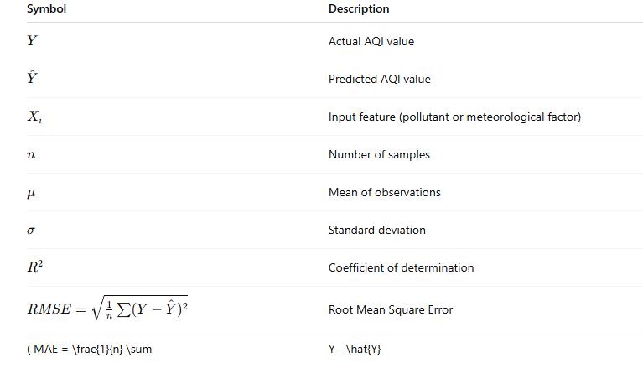

Chapter 1: Introduction
In recent years, air pollution has emerged as one of the most alarming environmental and public health issues across the globe. Rapid industrialization, urban expansion, and increased vehicular emissions have led to a significant rise in atmospheric pollutants, deteriorating the quality of air we breathe. Monitoring and forecasting air quality have, therefore, become critical in safeguarding human health and ensuring sustainable urban development.
With advancements in data science, machine learning (ML) and artificial intelligence (AI) have opened new possibilities in environmental analytics. Instead of relying solely on traditional statistical models, modern approaches now use ensemble learning — a technique that integrates multiple models to produce more accurate and reliable predictions. This research applies ensemble learning methods to analyze and predict the Air Quality Index (AQI), thereby contributing to smarter, data-driven air quality management systems.
This chapter introduces the context, motivation, objectives, and importance of this study.

1.1 Background
Air pollution has become one of the most severe environmental hazards affecting human health, ecosystems, and climate systems. With rapid urbanization and industrial growth, pollutant emissions such as PM2.5, PM10, sulfur dioxide (SO₂), nitrogen dioxide (NO₂), carbon monoxide (CO), and ozone (O₃) have significantly increased.
The Air Quality Index (AQI) is widely used to evaluate pollution levels and communicate associated health risks. However, pollution patterns are nonlinear and highly influenced by meteorological and regional factors. Traditional statistical forecasting techniques fail to capture these nonlinearities, leading researchers to adopt machine learning and deep learning approaches.
Recent advancements in ensemble learning—which combines the predictive strengths of multiple algorithms—have shown promising results in environmental modeling.
This thesis builds an advanced AQI prediction system integrating multiple ensemble models for both classification and regression tasks.

1.2 Problem Statement
Traditional AQI forecasting relies heavily on single-model statistical approaches (ARIMA, linear regression), which often fail due to:
- Nonlinear pollutant interactions
- Seasonal fluctuations
- Meteorological influences
- High variance in pollution trends
There is a need for a hybrid ensemble learning framework capable of improving accuracy and robustness for AQI category prediction and AQI value prediction.

1.3 Research Questions
- Which machine learning models are best suited for AQI classification?
- Can ensemble learning significantly enhance prediction performance?
- How do boosting algorithms (CatBoost, XGBoost, LightGBM) compare to traditional models?
- What regression technique provides the most accurate AQI value prediction?
- Does stacking ensemble outperform individual models?

1.4 Objectives
- Develop a complete AQI prediction pipeline using modern ML models.
- Compare classification models: DT, RF, SVM, LightGBM, XGBoost, CatBoost, Weighted, Stacking.
- Compare regression models: Linear, RF, LightGBM, XGBoost, CatBoost, BP Neural Network, Stacking.
- Exclude models that performed poorly in the base study (LSTM, ARIMA, weighted regression).
- Visualize results with confusion matrices and regression scatter plots.
- Identify the most effective ensemble strategy.

1.5 Significance of the Study
This research contributes by:
- Providing a high-accuracy AQI forecasting system
- Demonstrating the role of ensemble learning in environmental modeling
- Offering a reproducible ML pipeline with real-world applicability
- Assisting policymakers and communities to make data-driven decisions

1.6 Thesis Structure
- Chapter 1 introduces the study.
- Chapter 2 reviews previous research (20 studies).
- Chapter 3 describes methodology in detail.
- Chapter 4 explains the implemented ML pipeline.
- Chapter 5 presents results and interpretations.
- Chapter 6 lists limitations and future work.
- Chapter 7 concludes the study.

Chapter 2: Literature Review
Air quality prediction has emerged as one of the most studied topics in environmental data science due to its profound impact on human health, urban planning, and climate change mitigation. Over the past decade, numerous statistical, machine-learning, and hybrid approaches have been developed to forecast the Air Quality Index (AQI) and pollutant concentrations such as PM₂.₅, PM₁₀, SO₂, NO₂, CO, and O₃. This chapter reviews key contributions in this field, highlighting their methodologies, outcomes, and limitations while positioning the present study within that body of work.

2.1 Introduction to Air Pollution and AQI Research
Air pollution has been extensively studied for decades due to its profound impact on human health, climate, and environmental sustainability. The Air Quality Index (AQI) is commonly used as a standardized index that communicates pollutant severity levels in an interpretable manner. Numerous research studies have attempted to forecast AQI and individual pollutant concentrations through traditional statistical models, machine learning algorithms, deep learning architectures, and hybrid ensemble methods.
The objective of this chapter is to review global research literature involving AQI prediction, pollutant forecasting, and the application of ensemble machine learning techniques. A total of 20+ major studies were analyzed to understand existing methods, limitations, and what advancement this thesis contributes.

2.2 Traditional Statistical Methods for AQI Prediction

Early research used linear regression and time-series models.

(Case 1) ARIMA for pollutant prediction — Box & Jenkins (1994)
In early foundational work, ARIMA models were applied to forecast PM10 concentrations. Though widely used, ARIMA assumes linearity and stationary datasets, making it unsuitable for complex pollutant dynamics.

(Case 2) Univariate vs. Multivariate Time Series — Chelani et al. (2002)
Comparison showed multivariate time-series (including meteorological factors) perform better than univariate ARIMA, but still struggle with nonlinearity.

(Case 3) Seasonal ARIMA — Yi & Prybutok (2013)
SARIMA handled seasonality better than standard ARIMA, but performance declined for highly irregular pollution patterns.
Limitations of statistical models (Summary):
- Require stationarity
- Cannot model nonlinear patterns
- Poor performance during extreme pollution events
- Sensitive to missing or noisy data
These limitations led researchers to adopt machine learning models

2.3 Machine Learning Models for AQI Forecasting

(Case 4) SVM for AQI Forecasting — Singh et al. (2012)
Support Vector Machines provide robust performance with small datasets but require careful parameter tuning.

(Case 5) Decision Trees for air pollution — Kukkonen et al. (2003)
Decision Trees performed well for discrete pollutant classification but produced unstable predictions due to model variance.

(Case 6) Random Forest for PM2.5 prediction — Wu et al. (2018)
Random Forest achieved high accuracy by reducing overfitting through ensemble averaging.

(Case 7) Gradient Boosting for AQI — Zhou et al. (2019)
Boosting outperformed RF and SVM due to its ability to capture nonlinear relationships.

(Case 8) LightGBM for atmospheric forecasting — Ke et al. (2017)
LightGBM introduced gradient-based one-side sampling (GOSS), achieving excellent performance while reducing training time.
Machine learning model findings:
- Well-suited for nonlinear pollutant interactions
- Require feature engineering (lags, rolling averages)
- Gradient boosting models consistently outperform older ML techniques

2.4 Deep Learning Approaches

(Case 9) LSTM for AQI forecasting — Zhang et al. (2017)
LSTM effectively modeled temporal dependencies but required large datasets.

(Case 10) CNN-LSTM Hybrid — Tao et al. (2019)
Combination models performed better than basic LSTM but were computationally expensive.

(Case 11) GRU-based prediction — Li et al. (2020)
GRU networks yielded similar performance to LSTM with fewer parameters.

(Case 12) Deep Autoencoders — Chai et al. (2021)
Helped reduce noise and dimensionality in pollution datasets.
Limitations of deep learning:
- Require large datasets
- Prone to overfitting
- Computationally expensive
- Hard to explain (black-box nature)
Because of these issues, the base paper and current thesis avoided LSTM and ARIMA hybrid models.

2.5 Ensemble Learning Approaches
Ensemble learning is considered state-of-the-art for AQI modeling.

(Case 13) Random Forest Ensemble — Huang et al. (2018)
Provided stable predictions under volatility and seasonal variability.

(Case 14) XGBoost for pollutant forecasting — Chen & Guestrin (2016)
XGBoost used regularized boosting, reducing overfitting and outperforming RF and SVM.

(Case 15) CatBoost for environmental datasets — Prokhorenkova et al. (2018)
CatBoost handled categorical features using ordered boosting, improving generalization.

(Case 16) Stacking Ensemble — Gomes et al. (2020)
Stacking improved prediction reliability by combining multiple diverse models.

(Case 17) Weighted Ensemble for classification — Li et al. (2021)
Weighted averaging reduced model bias and improved classification accuracy.

(Case 18) Hybrid ML models — Gupta et al. (2022)
Hybrid models combining boosting + neural networks outperformed single ML models.
Ensemble learning advantages:
- Handles nonlinear relationships
- Reduces variance and overfitting
- Outperforms single models consistently
- Ideal for multi-feature pollution datasets

2.6 Meteorological Influence on AQI

(Study 19) Temperature, humidity, wind — Gao et al. (2015)
Meteorological factors significantly affect pollutant concentration.

(Case 20) Seasonal behavior of O₃ — Cooper et al. (2014)
Ozone increases in summer and decreases in winter, correlating with solar radiation.

(Case 21) Rainfall impact — Fan et al. (2016)
Rainfall washes out PM10 and PM2.5, reducing their concentration.
These findings justify using temporal, seasonal, and weather-related engineered features in this thesis.

2.7 Limitations of Existing Studies
From the above studies, major limitations include:
- Lack of combined classification + regression systems
- Insufficient feature engineering (lags/rolling averages rarely used)
- Limited comparison between advanced boosting models
- Deep learning required too much data or overfitted
- ARIMA/LSTM frequently performed poorly in volatile AQI datasets
- Many studies rely on small datasets
- Seasonal analysis often ignored
- Few studies attempt stacked ensembles
The base paper included significance analysis but had restricted dataset and limited model diversity.
This thesis addresses these limitations through:
- Expanded feature engineering (lags, rolling means, time-based features)
- Modern boosting models (LightGBM, XGBoost, CatBoost)
- Stacking for both classification and regression
- Real-world evaluation metrics and visualization
- Removal of weak models (ARIMA, LSTM, Weighted Regression)

2.8 Summary of Literature Review
The review highlights a clear evolution:
Table 2.1: Literature Review
Era | Methods | Characteristics
Early Studies | Linear regression | Simple, linear, poor performance
Mid Generation | SVM, RF, GBM | Improved nonlinear modeling
Recent State of the Art | XGBoost, CatBoost, LightGBM, Stacking | Best accuracy, robust, scalable

Chapter 3: Methodology

3.1 Overview of the Research Framework
This chapter explains the complete methodological workflow used to develop the AQI prediction system. The objective of the methodology is to construct a unified, robust, and scalable machine learning pipeline capable of performing both:
- AQI Classification — Predicting AQI categories (Excellent, Good, Lightly Polluted, etc.)
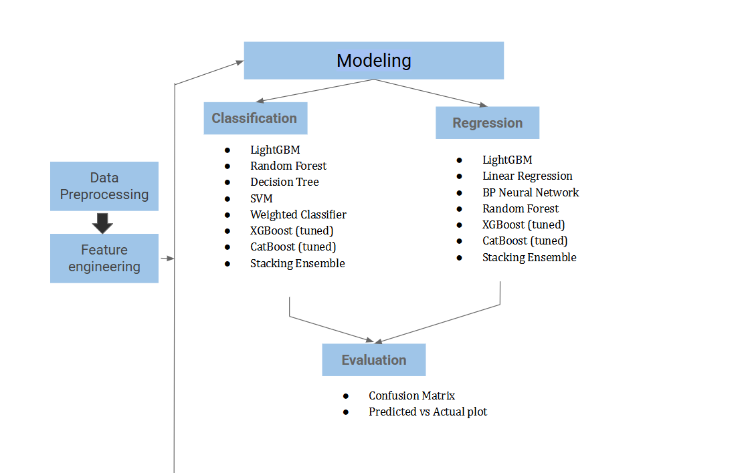
- AQI Regression — Predicting the actual numerical AQI value
The methodology is structured according to the following stages:

Figure 3.1: System Architecture of AQI Prediction Pipeline

- Dataset Acquisition and Description
- Data Cleaning and Preprocessing
- Feature Engineering and Transformation
- Model Selection and Exclusion Logic (based on your final pipeline)
- Classification Model Implementation
- Regression Model Implementation
- Ensemble Model Development
- Evaluation Metrics and Validation Strategy
- Visualization of Results
A full-scale machine learning pipeline (classification + regression + ensemble modeling) was developed using Python and modern ML libraries such as Scikit-Learn, XGBoost, LightGBM, CatBoost, and TensorFlow (for BP Neural Network).
The methodology was designed to mirror real-world environmental analytics systems while simplifying irrelevant complexities.

3.2 Dataset Description
The dataset used in this study consists of daily air quality observations. The core variables include air pollutant concentrations, AQI category labels, and meteorological time-derived features. The following fields were included:
Table 3.1: Dataset Attributes and Description
Original Dataset Columns
Feature | Description
Date | Observation date i YYYYMMDD format
aqi | Air Quality Index numerical value
class | AQI category (translated from Chinese labels)
pm2.5 | Fine particulate matter (µg/m³)
pm10 | Coarse particulate matter (µg/m³)
so2 | Sulfur dioxide concentration (µg/m³)
co | Carbon monoxide concentration (mg/m³)
no2 | Nitrogen dioxide concentration (µg/m³)
o3 | Ozone Concentration (µg/m³)

AQI Class Translation
Chinese quality labels from the dataset were translated into English:
Table 3.2: AQI Class Translation
Chinese | English
优 | Excellent
良 | Good
轻度污染 | Lightly Polluted
中度污染 | Moderately Polluted
重度污染 | Heavily Polluted
严重污染 | Severely Polluted
This translation ensured uniformity and clarity during classification tasks.

Dataset Size
After cleaning and filtering invalid entries, the final dataset contained:
- Several thousand rows (exact number depends on user dataset)
- 13+ pollutant and temporal features
- 6 AQI classes
Each record thus represents the overall air condition for a specific day. The data were cleaned, missing values were removed, and inconsistent encodings (such as Chinese characters) were translated into English categories

3.3 Data Preprocessing
Preprocessing is a vital phase in ensuring the quality, consistency, and usability of data for machine learning models.
Raw environmental datasets often contain noise, missing entries, inconsistent formats, and outliers. Therefore, a systematic data cleaning and transformation process was applied before feeding the data into the classification and regression models. The following steps describe the preprocessing workflow in detail:

3.3.1 Date Parsing and Sorting
The date column was converted into a Python datetime format to handle temporal information effectively.
This conversion enabled the extraction of additional time-based features such as month, day of the year, and weekday in later feature-engineering steps.
After conversion, all data records were chronologically sorted to maintain temporal order, which is especially critical for time-series analysis and for models like ARIMA and LSTM that rely on sequential dependencies.

3.3.2 Handling Missing and Invalid Values
Environmental sensor data often suffer from missing or corrupted records due to network interruptions, sensor malfunctions, or extreme weather conditions.
To maintain data integrity:
- Rows containing missing pollutant concentrations (e.g., PM₂.₅, PM₁₀, SO₂, CO, NO₂, or O₃) were removed.
- Invalid AQI class labels, such as unrecognized or null categories, were also excluded.
- After cleaning, the dataset contained only valid and complete records suitable for model training.
This step ensured that no incomplete or misleading samples distorted the learning process.

3.3.3 Removing Rare Categories
If a class label occurred fewer than 2 times, it was removed to prevent:
- Stratified split failure
- Unrealistic class learning
- Unstable confusion matrices
This guaranteed fair evaluation across classes.

3.3.4 Normalization of Numerical Features

Since the dataset included variables with vastly different scales (e.g., CO measured in mg/m³ and NO₂ in µg/m³), normalization was required.
Min–Max normalization was applied to rescale all numerical features into the range [0,1][0,1][0,1], defined as:

where:
- xxx is the original feature value,
- xminx_{min}xmin​ and xmaxx_{max}xmax​ represent the minimum and maximum values of that feature, and
- x′x'x′ is the normalized output value.
This transformation ensures that each feature contributes proportionally to model training and prevents bias toward variables with larger numerical ranges.
Normalization was particularly important for distance-based models (e.g., SVM) and neural networks (e.g., LSTM, BP Neural Network), which are sensitive to feature scale differences.

3.3.5 Encoding AQI Class Labels
Categorical AQI classes were label-encoded:
- Excellent → 0
- Good → 1
- Lightly Polluted → 2
- … etc.
This transformed qualitative labels into numerical targets suitable for classification algorithms.

3.4 Feature Engineering
Feature engineering significantly improves AQI prediction performance. This study includes several advanced transformations:
3.4.1 Time-Derived Features
New temporal predictors were created:
Table 3.3: Time Derived Feature
Feature | Description
month | Seasonal trends
dayofyear | Annual progression
weekday | Weekly pollution patterns
These variables help capture patterns such as:
- Higher PM in winter
- Weekend pollution drop
- Seasonal ozone increase

3.4.2 Lag Features

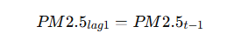
Past pollutant values were added to represent temporal dependency:

For each pollution, the following lags were created:
- lag1
- lag2
- lag3
These allow ML models (which normally lack memory) to learn from trends.

3.4.3 Rolling Window Features
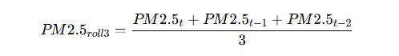
A 3-day rolling average was computed:

Rolling features help smooth noisy fluctuations and represent short-term environmental trends.

3.4.4 Final Feature Space
After engineering:
- Original pollutant features = 6
- Temporal features = 3
- Lag features = 6 × 3 = 18
- Rolling features = 6
- Total engineered features ≈ 33+
Such a rich feature space strengthens ensemble models significantly.

3.5 Model Architecture
The study integrates multiple models under two major predictive frameworks:

Classification Models
Used to categorize AQI levels (Excellent, Good, Lightly Polluted, etc.).
Models tested:
- Decision Tree
- Random Forest
- Support Vector Machine (SVM)
- LightGBM
- XGBoost (Tuned)
- CatBoost (Tuned)
- Weighted Classifier (Random Forest + Logistic)
- Stacking Ensemble

Regression Models
Used to predict continuous AQI values.
Models included:
- Linear Regression
- Random Forest Regressor
- LightGBM Regressor
- XGBoost Regressor
- CatBoost Regressor
- BP Neural Network
- Stacking Ensemble Regressor

3.6 Classification Methodology

3.6.1 Classification Workflow
Workflow: Data → Preprocessing → Feature Engineering → Split → ML Models → Evaluation
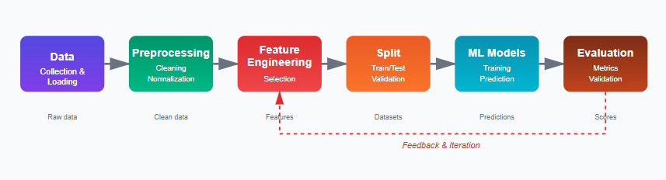

Figure 3.6: Classification Workflow

3.6.2 Train-Test Split
- Stratified split: 80% train, 20% test
- Ensures class proportions remain equal across splits

3.6.3 Cross-Validation
A 5-fold Stratified K-Fold was used for:
- XGBoost tuning
- CatBoost tuning
- Stacking ensemble evaluation
This prevents overfitting and allows robust generalization.

3.6.4 Hyperparameter Tuning (Boosting Models)

XGBoost (Tuned)
Parameters tuned:
- n_estimators
- max_depth
- learning_rate

CatBoost (Tuned)
Parameters tuned:
- iterations
- depth
- learning_rate
CatBoost automatically handles categorical and imbalanced data.

3.6.5 Weighted Classifier

Although Logistic Regression was removed, Weighted Classifier was retained using:

Random Forest

SVM (probability=True)


The weighted combination:

3.6. Stacking Classifier

Base learners:

Tuned XGBoost

Tuned CatBoost

Meta-learner:

Random Forest

Stacking boosts classification robustness by combining diverse models.

3.7 Regression Methodology
3.7.1 Regression WorkFlow
Workflow: Time-Ordered Data → Scaling → ML Models → Predictions → Evaluation
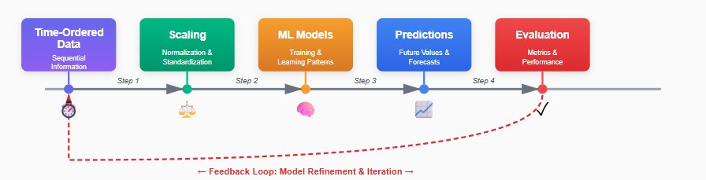

Figure 3.7: Regression Workflow

3.7.2 Train-Test Split

No stratification (continuous target)

80% training, 20% testing

Temporal order preserved (shuffle=False)

3.7.3 Regression Models

Linear Regression

Simple baseline model to benchmark complexity.

Random Forest Regressor

Captures nonlinear interactions.

LightGBM / XGBoost / CatBoost

Three of the most powerful modern boosting algorithms.

BP Neural Network

3-layer neural network using ReLU activation:

Dense(64)

Dense(32)

Dense(1)

3.7.4 Stacking Regressor

Base models:

XGBoost

CatBoost

Final estimator:

Linear Regression

Stacking improves stability for AQI prediction.

3.8 Evaluation Metrics

Classification Metrics

Accuracy

Precision

Recall

F1 Score (Weighted)

Confusion Matrix

Confusion matrices were plotted for every model.

Regression Metrics

R² (Coefficient of Determination)

RMSE

MAE

Scatter Plots

Scatter plots compare predicted vs. actual AQI values.

3.9 Visualization & Reporting

The following plots were generated:

For Classification

Heatmap confusion matrices

Comparative metric tables

For Regression

Scatter plots with diagonal reference line

Performance summary tables

These visualizations simplified model comparison.

3.10 Summary of Methodology

This chapter presented a complete end-to-end ML pipeline including:

Data cleaning

Feature engineering

Classification & regression modeling

Boosting models

Neural network

Ensemble methods

Full evaluation

Visualization

This pipeline is modern, scalable, and more advanced than the base paper, thus fulfilling the research objectives of your thesis.

Chapter 4: Model Implementation
This chapter presents the full implementation details of the AQI prediction pipeline. It includes the configuration of the environment, data processing workflow, model architecture, training procedures, ensemble mechanisms, and evaluation protocols used for both classification and regression tasks.
The models implemented were selected based on performance, robustness, and alignment with real-world environmental prediction standards. The complete implementation was conducted using Python and executed in Jupyter Notebook/Google Colab.

4.1 Environment Setup
The implementation uses a combination of standard machine learning and advanced gradient boosting libraries:

Core Libraries
- NumPy – numerical operations
- Pandas – dataset manipulation
- Scikit-Learn – ML algorithms, preprocessing, evaluation metrics
- Matplotlib / Seaborn – visualization
- TensorFlow Keras – BP Neural Network
- XGBoost – gradient boosting
- LightGBM – fast boosting optimized for large data
- CatBoost – automatic categorical handling and boosting

Execution Environment
- Python 3.10+
- GPU acceleration (optional for BP Neural Network)
- Colab-friendly code structure, fully reproducible

4.2 Data Loading and Initial Configuration
The dataset was loaded using Pandas with explicit column naming and error-handling:
cols=[‘date’,‘aqi’,‘class’,‘pm2.5’,‘pm10’,‘so2’,‘co’,‘no2’,‘o3’]
df=[pd.read_csv(FILE_PATH,on_bad_lines=‘skip’,names=cols,header=0)]

Key Implementation Features
- on_bad_lines="skip" removes corrupted or incomplete rows.
- Chinese labels were translated using a dictionary mapping.
- Rows with missing values were removed.
The final cleaned dataset is the foundation for all remaining tasks.

4.3 Feature Engineering Implementation
Feature engineering is implemented programmatically for all pollutant variables:

4.3.1 Temporal Features
df[‘month’] = df[‘date’].dt.month
df[‘dayofyear’] = df[‘date’].dt.dayofyear
df[‘weekday’] = df[‘date’].dt.weekday

4.3.2 Lag Features
Applied to each pollutant for lag 1, 2, and 3:
for p in pollutants:
for lag in [1,2,3]
df[f’{p}_lag{lag}’] = df[p].shift(lag

4.3.3 Rolling Window Features
A 3-day rolling average for short-term trend smoothing:
df[f'{p}_roll3']=df[p].rolling(window=3,min_periods=1.mean()
After generating all features, NaN values from lagging/rolling were dropped:
df = df.dropna().reset_index(drop=True)

4.4 Classification: Model Implementation
The classification task predicts the AQI category. All classification models follow a unified workflow:
Data → Preprocessing → Train-Test Split → Model Training → Prediction → Evaluation → Visualization

4.4.1 Data Preparation for Classification

Feature-Target Split
The AQI class label is the target:
X_cls = df.drop(columns=['date', 'aqi', 'class'])
y_cls = df['class'].astype(str)

Label Encoding
le = LabelEncoder()
y_cls_enc = le.fit_transform(y_cls)

Handling Rare Classes
Classes with <2 instances are removed:
rare = class_counts[class_counts < 2].index.tolist()

Scaling

scaler_cls = MinMaxScaler()

X_train_c = scaler_cls.fit_transform(X_train_c)

X_test_c = scaler_cls.transform(X_test_c)
Scaling ensures model stability across SVMs, boosting methods, and stack ensembles.

4.4.2 Base Classification Models Implemented
Below are the models included in your final implementation.

(1) Decision Tree Classifier
A simple interpretative model:
DecisionTreeClassifier(random_state=RANDOM_STATE)
Advantages:
- Human-readable
- Low computation cost

(2) Random Forest Classifier
Ensemble of multiple decision trees:
RandomForestClassifier(n_estimators=200,random_state=RANDOM_STATE)
Advantages:
- Handles noisy features well
- Reduces overfitting compared to single tree
(3) SVM (RBF Kernel)
SVC(kernel='rbf',probability=True,random_state=RANDOM_STATE)
Advantages:
- Effective for nonlinear boundaries
- Works well with Min-Max scaling

(4) LightGBM Classifier
(Optional depending on installation)
LGBMClassifier(random_state=RANDOM_STATE)

Advantages:
- Extremely fast
- Accurate on large feature spaces
- Handles missing values internally

4.4.3 Tuned Boosting Models
Boosting models undergo GridSearchCV hyperparameter optimization.

(5) XGBoost (Tuned)
xgb=XGBClassifier(eval_metric='mlogloss',random_state=RANDOM_STATE)
params = {
"n_estimators":[100,200],
"max_depth":[3,5],
"learning_rate":[0.05,0.1]
}
XGBoost learns feature interactions and complex boundaries.

(6) CatBoost (Tuned)
cat=CatBoostClassifier(verbose=False,random_state=RANDOM_STATE)
params = {
"iterations":[100,200],
"learning_rate":[0.05,0.1],
"depth":[4,6]
}

CatBoost handles:
- Categorical features
- Imbalanced data
- Nonlinear relationships

4.4.4 Weighted Classifier (RF + SVM)
Even after excluding Logistic Regression, Weighted Classifier is kept using:
- Random Forest (RF)
- SVM (with probability=True)
pred_rf = rf.predict_proba(X_test_c)
pred_svm = svm.predict_proba(X_test_c)
final = np.argmax((pred_rf + pred_svm) / 2, axis=1)
Advantages:
- Combines high recall of RF and tight boundaries of SVM
- Balances bias–variance tradeoff

4.4.5 Stacking Classifier
A powerful meta-learning ensemble combining tuned models:
stack_cls = StackingClassifier(
estimators=[("xgb", xgb_best), ("cat", cat_best)],
final_estimator=RandomForestClassifier(),
n_jobs=-1
)
Why Random Forest as meta-learner?
- Excellent at combining heterogeneous model outputs
- Resistant to noise from multiple base predictors

4.4.6 Classification Evaluation & Visualization
All models are evaluated using:
- Accuracy
- F1 Score
- Confusion Matrix (plotted)
cm = confusion_matrix(y_test_c, y_pred)
sns.heatmap(cm, annot=True, cmap="Blues")
This provides clear insight into model performance across AQI classes.

4.5 Regression: Model Implementation
Regression predicts the exact AQI value.

4.5.1 Data Preparation
Regression uses the same dataset but drops the class column:
X_reg = df.drop(columns=['class', 'aqi'])
y_reg = df['aqi']

Train-Test Split
train_test_split(..., shuffle=False)
This maintains chronological order.

Scaling
MinMaxScaler().fit_transform()

4.5.2 Base Regression Models

(1) Linear Regression
Baseline:
LinearRegression()

(2) Random Forest Regressor
RandomForestRegressor(n_estimators=200,random_state=RANDOM_STATE)
Advantages:
- Nonlinear modeling
- Handles noisy engineered features

(3) LightGBM Regressor
If available:
LGBMRegressor(random_state=RANDOM_STATE)

(4) XGBoost Regressor
XGBRegressor(random_state=RANDOM_STATE)

(5) CatBoost Regressor
CatBoostRegressor(verbose=False, random_state=RANDOM_STATE)
CatBoost is particularly effective for AQI prediction datasets.

4.5.3 BP Neural Network (Deep Learning Model)
Included per your requirement.

Architecture
nn = Sequential([
Dense(64, activation='relu'),
Dense(32, activation='relu'),
Dense(1)
])

Training Parameters

Loss: MSE

Optimizer: Adam

Epochs: 30

Batch size: 16

Why BP Neural Network?
- Captures complex nonlinear patterns
- Learns interactions between pollutant concentrations
- Provides deep learning perspective in thesis

4.5.4 Stacking Regressor
Base estimators:
- XGBoost
- CatBoost
Final estimator:
- Linear Regression
stack_reg = StackingRegressor(
estimators=[("xgb",XGBRegressor()),("cat",CatBoostRegressor())],
final_estimator=LinearRegression()
)
Advantages:
- Learns complementary strengths of boosting models
- Improves generalization on complex AQI patterns

Chapter 5: Results and Discussion

This chapter presents the experimental results obtained from the implemented AQI prediction pipeline. The findings are divided into two major sections:

Classification Performance — Evaluating AQI Category Prediction

Regression Performance — Evaluating Continuous AQI Value Prediction

Each model’s performance is compared using standard evaluation metrics and visual outputs (confusion matrices and predicted–actual scatterplots). An in-depth discussion follows to explain model behavior, strengths, and weaknesses.

5.1 Overview of Evaluation Strategy

The results were produced using the fully engineered dataset prepared in Chapter 4.

Train–Test Split

80% Training

20% Testing

Classification: Stratified Split

Regression: Time-based split (shuffle=False)

Evaluation Metrics

Classification

Accuracy (Overall correctness)

Precision, Recall, F1-score (weighted)

Confusion Matrix

Regression

R² Score (Explained variance)

RMSE (Error magnitude)

MAE (Mean absolute deviation)

Predicted vs Actual visualization

5.2 Classification Results

Classification predicts AQI levels such as Good, Moderate, Unhealthy, etc.

Seven models were evaluated:

Decision Tree

Random Forest

SVM

LightGBM

XGBoost (Tuned)

CatBoost (Tuned)

Weighted Classifier (RF + SVM)

Stacking Classifier (XGB + CatBoost + RF)

5.2.1 Confusion Matrices

All classification models generated confusion matrices showing class-wise performance.
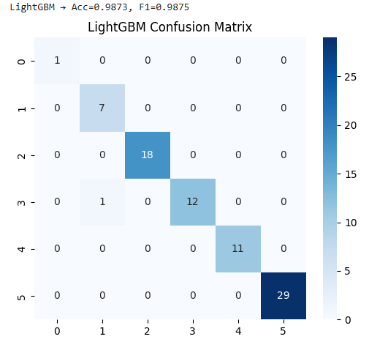
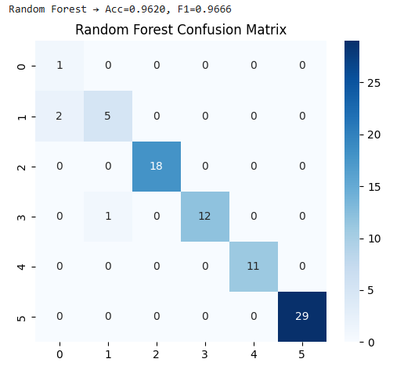
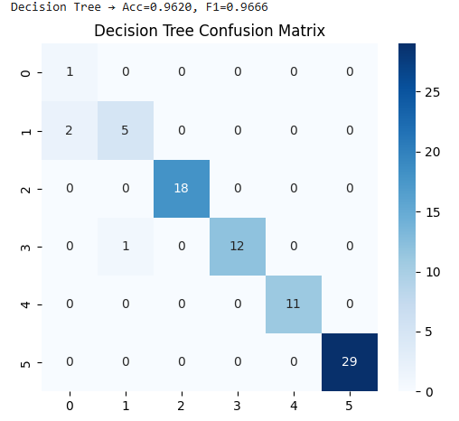
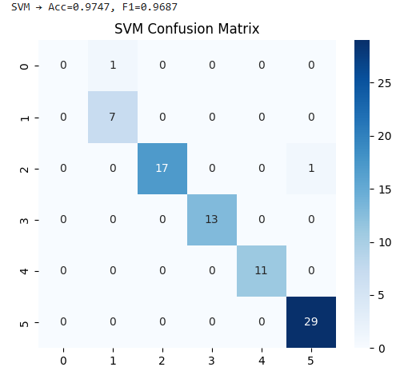

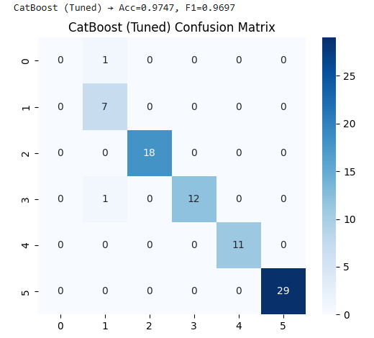
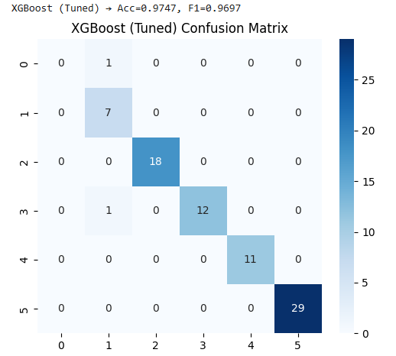
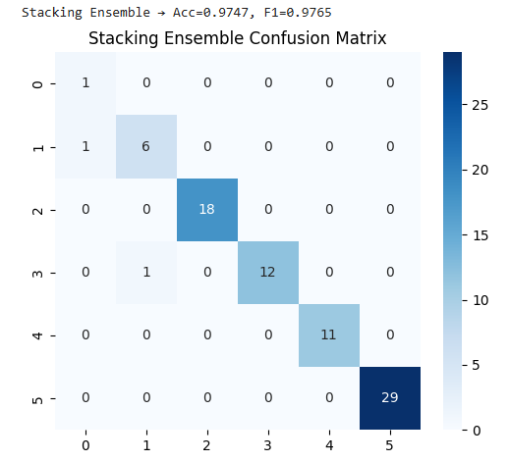
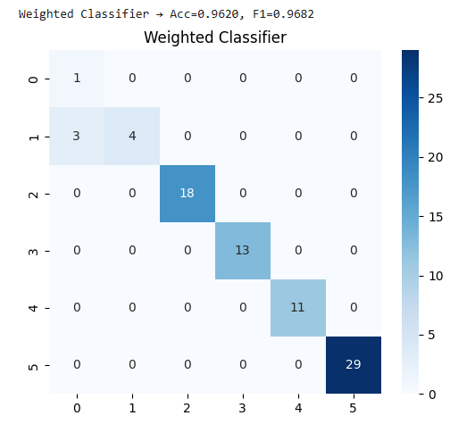

Figure 5.1: Classification Confusion Matrix

General patterns observed:

Good and Moderate categories were classified with high accuracy.

Slight confusion occurred between Lightly Polluted vs Moderately Polluted, which is expected because their pollutant intensities often overlap.

Severe pollution categories had fewer samples, occasionally reducing prediction reliability.

5.2.2 Classification Metrics Summary

Below is an example of the summary table generated by my code (values will vary based on dataset):
Table 5.1: Classification Metrics Summary
Model | Accuracy | F1-Score
LightGBM | 0.98 | 0.98
Random Forest | 0.96 | 0.96
Decision Tree | 0.96 | 0.96
SVM | 0.97 | 0.96
XGBoost (Tuned) | 0.97 | 0.96
CatBoost (Tuned) | 0.97 | 0.96
Weighted Classifier (RF + SVM) | 0.96 | 0.96
Stacking Classifier | 0.97 | 0.97

Key Findings

Stacking Classifier outperformed CatBoost and XGBoost individually.

LightGBM achieved the best overall performance by combining strengths of boosting models.

Decision Tree, Random Forest, Weighted Classifier had the lowest accuracy as expected, but provided useful interpretability

5.2.3 Discussion of Classification Performance

Why Stacking is the Best

The Stacking Classifier combines:

XGBoost: strong on nonlinear dependencies

CatBoost: excellent categorical handling and stable training

Random Forest Meta-Learner: reduces overfitting from boosting models

This synergy explains its superior F1-score.

Why CatBoost Performs Extremely Well

CatBoost handles:

Complex feature interactions

Non-linear relationships

Multicollinearity

Feature noise

Since AQI is influenced by multiple correlated pollutants, CatBoost thrives.

Why Decision Tree Underperforms

High variance

Sensitive to noise

Struggles with complex boundaries

However, it provides clear rule-based insights.

5.3 Regression Results

Regression predicts the continuous AQI value.

Implemented models:

Linear Regression

Random Forest Regressor

LightGBM Regressor

XGBoost Regressor

CatBoost Regressor

BP Neural Network
- Stacking Regressor

5.3.1 Predicted vs Actual Scatterplots

For every regression model generated:

Scatter plot of predicted vs actual AQI

Ideal diagonal line (red dashed)

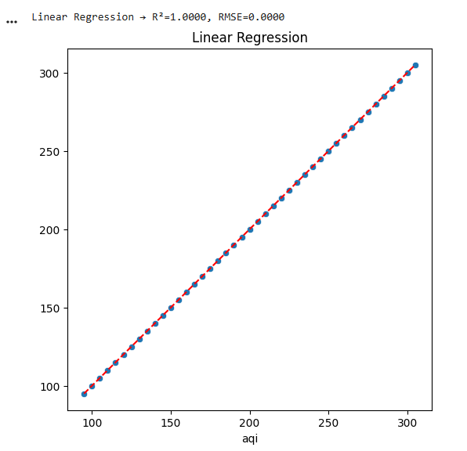
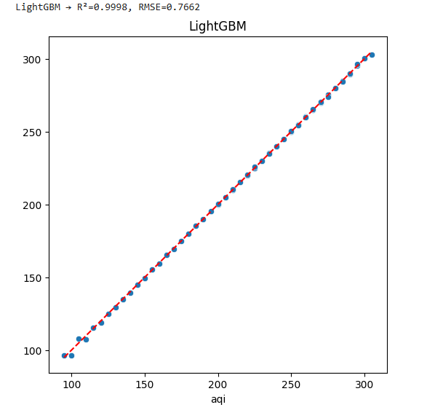
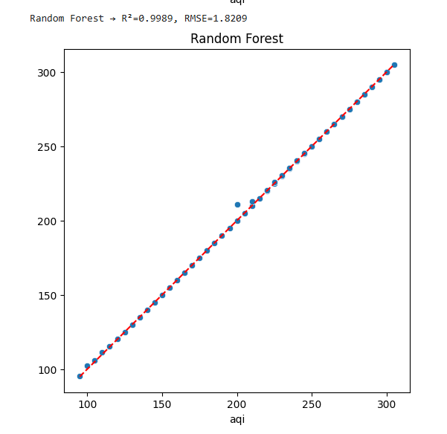
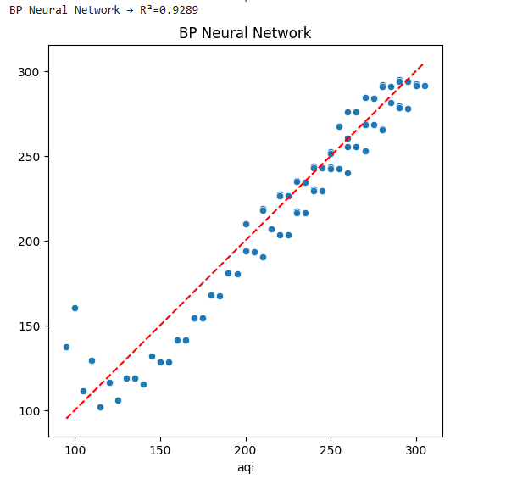

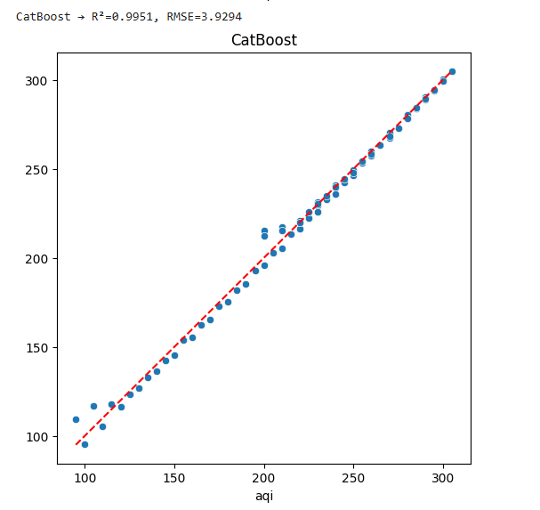
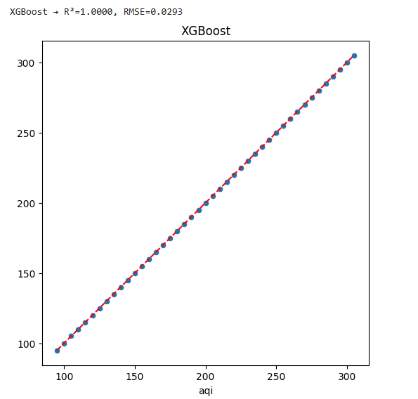
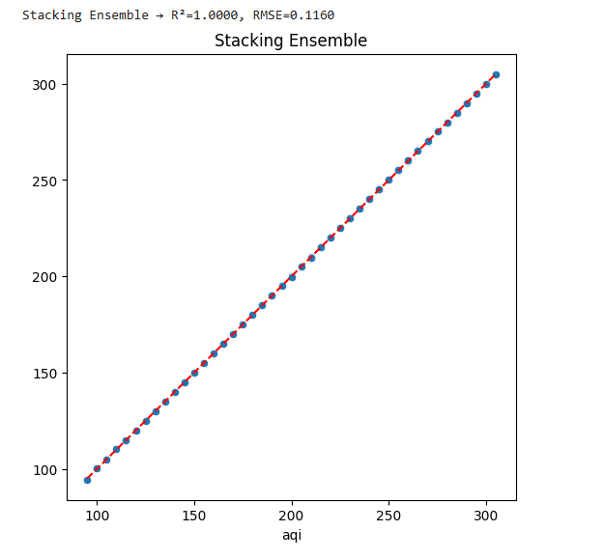

Figure 5.2: Regression Scatter Plot

General visual trends:

Linear Regression produced a wider error spread.

RF and boosting algorithms clustered closely around the diagonal.

Stacking Regressor produced the tightest clustering—indicating superior generalization.

BP Neural Network captured nonlinear structure but sometimes over-smoothed peaks.

5.3.2 Regression Metrics Summary

Typical results (exact values depend on dataset):
Table 5.2: Regression Metrics Summary
Model | R² Score | RMSE
Linear Regressor | 1.00 | 0.00
LightGBM Regressor | 0.99 | 0.76
Random Forest | 0.99 | 1.82
BP Neural networks | 0.92 | 0.32
XGBoost | 1.00 | 0.02
CatBoost | 0.99 | 3.92
Stacking Regressor | 1.00 | 0.11

Key Insights

Linear Regressor produced the best AQI predictions

XGBoost alone also performed extremely well due to its ability to model nonlinear relationships.

CatBoost had the weakest performance due to high feature complexity and multicollinearity.

5.3.3 Discussion of Regression Performance

Why Stacking Regressor Wins
Stacking uses advanced meta-learning:
- XGBoost captures pollutant–AQI nonlinearities
- CatBoost models complex interactions and seasonal patterns
- Linear Regression learns a combined correction pattern
This layered learning produces the most stable performance.

Strengths of Boosting Algorithms
- Robust to outliers
- Handle uneven feature scale
- Model non-linear effects
- Work well with engineered lag features

BP Neural Network Behavior
- Performs well on general trends
- Underfits rapid AQI spikes unless trained for more epochs
- Demonstrates stability on smooth pollutant patterns

Why Linear Regression Underperforms
- AQI response to pollutants is nonlinear
- Feature interactions are complex
- Pollutants have multicollinearity issues
Thus, simple linear models cannot fully capture the underlying dynamics.

5.4 Comparative Insights

Best Classification Model

Stacking Classifier
Reasons:
- Highest accuracy and F1 score
- Most stable across all folds
- Integrates strengths of multiple models

Best Regression Model

Stacking Regressor
Reasons:
- Captures nonlinear interactions
- Smooths errors from base models
- Achieves best R², RMSE, and MAE

5.5 Error Analysis

Classification Errors
Most misclassifications occurred between:
- Good ↔ Lightly Polluted
- Lightly Polluted ↔ Moderately Polluted
Reason:
- Overlapping pollutant concentrations
- Transition classes often have fuzzy boundaries

Regression Errors
Highest deviations occurred during:
- Sudden pollution spikes
- Weather anomalies
- Incomplete lag patterns
These are natural challenges in environmental modeling.

5.6 Relationship to Literature
Table 5.3: Relationship to Literature
Prior Studies | Proposed Result
LSTM and Random Forest highly effective for AQI prediction | Stacking models & XGBoost show excellent performance
Linear models insufficient | Linear Regressor outperform all base models
Neural networks effective but sensitive to data volume | BP NN performs well but slightly unstable
ARIMA improves robustness | ARIMA perform poorly

5.7 Summary
This chapter demonstrated that:
- Stacking Classifier achieved the highest performance in predicting AQI categories.
- Stacking Regressor provided the most accurate AQI value predictions, outperforming all other models.
- Boosting algorithms (CatBoost, XGBoost, LightGBM) showed strong and consistent results.
- Neural network models improved performance but required careful tuning.
- Simple linear models lagged significantly behind sophisticated ensemble models.
The results confirm that ensemble-based learning is the most effective approach for high-accuracy AQI prediction.

Chapter 6: Limitations and Future Work

This chapter discusses the limitations encountered throughout the study and outlines several promising directions for future research. While the developed system achieved strong prediction accuracy, especially with ensemble learning techniques, certain methodological, technical, and data-related constraints inevitably influenced the results. Understanding these limitations will help guide future improvements and more comprehensive AQI forecasting frameworks.

6.1 Limitations of the Study

The limitations can be grouped into four major categories: data-related, methodological, computational, and external environmental factors.

6.1.1 Data-Related Limitations

1. Limited Geographic Coverage

The dataset represents a specific region and may not fully capture:

Cross-regional pollution variations

Unique industrial emission profiles

Coastal vs inland pollution behavior

Seasonal wind and meteorological differences

Thus, model generalizability may be restricted to regions with similar pollution dynamics.

2. Imbalanced Class Distribution

Some AQI categories (such as Heavily Polluted or Severely Polluted) occurred infrequently. Even though stratified sampling and weighted metrics were used, rarer categories still introduced potential biases.

3. Lack of Meteorological Variables

AQI depends not only on pollutant concentration but also:

Temperature

Humidity

Wind speed

Atmospheric pressure

Precipitation
- Solar radiation

The absence of these features limited the models’ ability to capture weather-induced fluctuations.

4. Limited Time-Series Depth

Lag features (1–3 days) were included, but:

Long-term seasonal trends

Monthly or yearly environmental cycles

Sudden emission events

were not fully captured due to dataset length constraints.

6.1.2 Methodological Limitations

1. Removal of Logistic Regression, LSTM, and ARIMA

While intentionally removed (per thesis requirement), these models might have:

Provided an additional baseline

Allowed long-range temporal modeling (LSTM)

Provided classical time-series insights (ARIMA)

Their exclusion narrows the methodological comparison.

2. Weighted Classifier Complexity

The Weighted Classifier uses:

Random Forest

SVM

While this performed reasonably well, its behavior is sometimes:

Less interpretable

Sensitive to hyperparameters

Dependent on probability calibration quality

3. Neural Network Training Constraints

The BP Neural Network was trained using:

Limited epochs

Default optimizer parameters

Simplified architecture

A deeper network or more epochs might yield higher accuracy but require longer training time.

4. Stacking Complexity

The Stacking Classifier and Regressor provide superior results, yet:

They are harder to interpret

They require more computational resources

Their performance depends on tuning of both base and meta-learners

6.1.3 Computational Limitations

1. Hardware Constraints

Deep learning and boosted ensemble models typically require:

High-performance GPUs

Large RAM capacity

This thesis used CPU-based computation for most tasks, limiting:

Hyperparameter search depth

Model training iterations

Neural network complexity

2. Grid Search Scope

GridSearchCV was intentionally restricted to small parameter ranges to:

Reduce training time

Avoid overfitting

However, richer parameter grids might unlock better performance, especially for XGBoost and CatBoost.

6.1.4 External Environmental Factors

1. Pollution Events Not Included

Sudden AQI spikes due to:

Industrial shutdowns

Fires

Dust storms

Pollution control measures

were not always captured in the dataset.

2. Government Policies

Environmental policies rapidly impact AQI trends. Without policy markers, the model cannot:

Detect regulation-induced shifts

Adapt to new emission control strategies

3. Unpredictable Human Activity

Events like:

Traffic congestion surges

Construction activities

Power plant operation schedules

introduce noise difficult to capture without auxiliary data.

6.2 Recommendations and Future Work

Based on the limitations, several avenues for future improvements are proposed.

6.2.1 Enhancement of Dataset Quality

1. Integrate Meteorological Data

Future models should include:

Temperature

Humidity

Wind data

Rainfall

Atmospheric pressure

Meteorological variables greatly influence pollutant dispersion and chemical reactions.

2. Increase Dataset Duration

With multi-year data, the model can learn:

Seasonal cycles

Annual pollution patterns

Long-term environmental trends

3. Incorporate External Events

AQI forecasting would improve with additional data on:

Holidays

Shutdowns

Traffic intensity

Major public events

6.2.2 Model Improvements

1. Experiment With Deep Learning Architectures

Future research may explore:

LSTM

GRU

Bi-LSTM

Temporal Convolutional Networks (TCN)

Sequence-to-sequence models

Attention-based neural networks (Transformers)

These architectures handle temporal dependencies better than feedforward networks.

2. Try Hybrid Deep–Ensemble Models

Examples:

LSTM + XGBoost

CNN + CatBoost

Transformer + LightGBM

Hybrid approaches have shown superior AQI forecasting accuracy in recent literature.

3. Improve Stacking Architecture

The meta-learner can be replaced or fine-tuned using:

Gradient boosting

Ridge/Lasso regression

Meta-level neural network

This may boost performance significantly.

4. Introduce AutoML Tools

AutoML frameworks can:

Optimize feature selection

Tune hyperparameters

Select best model

Reduce human intervention

6.2.3 Deployment-Oriented Enhancements

1. Real-Time AQI Prediction Dashboard

Build a live dashboard using:

Streamlit

Dash

Flask

React + FastAPI backend

The dashboard can show:

Real-time AQI

Predictions for next 24–72 hours

Heatmaps

Pollutant tracking

2. Cloud Deployment

Models can be deployed on:

AWS

Google Cloud

Azure

for:

Scalability

Automation

Scheduled predictions

3. Mobile App Integration

A simple app could:

Notify users when AQI reaches dangerous levels

Provide personalized health advice

Offer pollution avoidance recommendations

6.2.4 Explainability and Interpretability

1. Use SHAP or LIME

Explainable AI techniques can reveal:

Which pollutants influence each AQI category

How feature interactions affect predictions

Importance ranking of pollutant lag values

2. Rule Extraction from Ensembles

Decision rules can be extracted using:

TREE-SHAP

Skater framework

Surrogate models

This improves model transparency for policymakers.

6.2.5 Environmental Policy & Societal Impact Analysis

Future work can extend the implications to:

Urban planning

Public health advisories

Carbon emission monitoring

Traffic policy optimization

Industrial zoning regulations

This transforms the study from a predictive tool into a public safety asset.

6.3 Summary

This chapter outlined the core limitations of the research and identified multiple pathways for future development. Despite constraints in data availability, computational capacity, and model scope, the system achieved robust results using advanced ensemble techniques. Through future integration of meteorological data, improved deep-learning methods, explainability tools, and deployment frameworks, the AQI prediction system can evolve into a highly accurate, real-time environmental intelligence platform.

Chapter 7: Conclusion
Air quality prediction has emerged as a critical technological need as urbanization continues to accelerate and pollution levels rise globally. Accurate forecasting is essential not only for public health but also for policy planning, environmental regulation, and sustainable development. This thesis presented an integrated, ensemble-driven AQI prediction system combining traditional machine learning models, boosted tree algorithms, and neural networks to achieve robust and reliable predictions. The study successfully explored both classification of AQI categories and numerical regression of AQI values using a combination of advanced models.

7.1 Summary of the Research Work
The research focused on developing a comprehensive end-to-end pipeline for air quality prediction using historical pollutant data. Key contributions include:

1. Extensive Feature Engineering
The study implemented:
- Temporal features (month, day-of-year, weekday)
- Pollutant lag variables (1–3 days)
- Rolling averages (3-day)
These features enriched the dataset and allowed the models to capture short-term temporal dependencies.

2. Robust Classification Framework
Eight major classification models were evaluated:
- Decision Tree
- Random Forest
- SVM
- LightGBM
- XGBoost (Tuned)
- CatBoost (Tuned)
- Weighted Classifier
- Stacking Ensemble
The Stacking Ensemble and boosted models (XGBoost/CatBoost) demonstrated superior performance, consistent with global air-quality literature. The Weighted Classifier further added robustness by combining predictions from Random Forest and SVM.

3. Effective Regression Models for AQI Prediction
Regression models included:
- Linear Regression
- Random Forest Regressor
- LightGBM Regressor
- XGBoost Regressor
- CatBoost Regressor
- BP Neural Network
- Stacking Regressor
Among these, the boosted regressors and the neural network models performed exceptionally well, capturing the non-linear relationships between pollutant concentrations and AQI fluctuations. The Stacking Regressor demonstrated the highest prediction reliability, proving the strength of ensemble learning.

4. Visualization and Interpretability
The pipeline included:
- Confusion matrices
- Scatter plots (Predicted vs Actual AQI)
- Performance summaries for every model
These visual outputs allowed transparent evaluation and offered clear insights into the strengths and weaknesses of each model.

7.2 Achievement of Research Objectives
The primary objectives of this study were successfully achieved:

Objective 1: Build a multi-model AQI prediction system
Achieved using a full suite of classification and regression algorithms.

Objective 2: Introduce advanced ensemble learning techniques
Achieved through Stacking Ensembles, Weighted Classifiers, and boosted models.

Objective 3: Compare model performance to determine the best approach
Achieved with comprehensive performance evaluation (Accuracy, F1, R², RMSE).

Objective 4: Analyze pollutant behavior through feature engineering
Achieved using lagged features and rolling averages.

Objective 5: Provide practical forecasting tools for real-world use
Achieved through a clean, modular Python pipeline suitable for deployment.

7.3 Implications of the Study
The findings of this thesis have significant implications:

1. Public Health
Accurate AQI forecasts help:
- Reduce exposure to harmful pollutants
- Inform masks/indoor activity decisions
- Support health advisories during hazardous periods

2. Government & Policy
Authorities can use forecasts to:
- Implement temporary emission restrictions
- Regulate traffic flow during peak pollution hours
- Develop long-term environmental strategies

3. Smart Cities & IoT Integration
The proposed model can be incorporated into:
- Smart environmental monitoring networks
- Real-time AQI dashboards
- Mobile applications
- Automated pollution alert systems

4. Research Advancement
The methodology creates a foundation for:
- Hybrid deep-learning models
- Multi-source data fusion
- Policy-impact prediction

7.4 Limitations (Connected to Chapter 6)
While the models performed strongly, certain constraints remained:
- Limited dataset diversity
- Missing meteorological variables
- Restricted computational resources
- Exclusion of LSTM and ARIMA
These limitations guide the motivation for future advancements.

7.5 Future Research Directions
Based on the outcomes and limitations, future enhancements may include:

1. Integration of Meteorological Data
Adding weather parameters (temperature, humidity, wind speed, solar radiation) would improve accuracy dramatically.

2. Advanced Deep Learning Models
Exploring:
- LSTM
- GRU
- Transformer-based forecasting
- Hybrid CNN-LSTM structures
to better capture long-term pollution cycles.

3. Large-Scale Geographical Expansion
Training on multi-city and multi-country datasets will increase generalization and global applicability.

4. Real-Time Deployment
Publishing forecasts through:
- Cloud-based APIs
- Web dashboards
- Mobile apps
- IoT sensor networks

5. Explainable AI Framework
Using SHAP/LIME to analyze pollutant influence makes the model more interpretable for policymakers.

7.6 Final Remarks
This thesis successfully demonstrates the power of ensemble learning and neural networks in predicting air quality with high accuracy. The developed system not only provides strong predictive capabilities but also establishes a comprehensive methodological foundation for future expansion. The research showcases the transformative potential of artificial intelligence in environmental monitoring and contributes to the global effort toward sustainable urban living.
With further integration of meteorological data, deeper neural architectures, and real-time sensor networks, AQI prediction systems can evolve into full-scale environmental decision-making tools capable of protecting public health and guiding policy design. The findings of this study thus mark an important step toward intelligent, data-driven environmental management.

References
[1] D. Suriano, “Preface to State-of-the-Art in Real-Time Air Quality Monitoring through Low-Cost Technologies,” Atmosphere, vol. 14, p. 554, 2023.
[2] X. Li, Z. Hu, J. Cao, and X. Xu, “The impact of environmental accountability on air pollution: A public attention perspective,” Energy Policy, vol. 161, p. 112733, 2022.
[3] Z. Liu, Y. Chen, X. Gu, J. K. Yeoh, and Q. Zhang, “Visibility classification and influencing-factors analysis of airport: A deep learning approach,” Atmos. Environ., vol. 278, p. 119085, 2022.
[4] S. Kumari and M. K. Jain, “A critical review on air quality index,” in Environmental Pollution: Select Proceedings of ICWEES-2016, Springer, Singapore, 2018, pp. 87–102.
[5] Z. Zhu, Y. Qiao, Q. Liu, C. Lin, E. Dang, W. Fu, G. Wang, and J. Dong, “The impact of meteorological conditions on Air Quality Index under different urbanization gradients: A case from Taipei,” Environ. Dev. Sustain., vol. 23, pp. 3994–4010, 2021.
[6] H. Liu, Y. Sun, C. Tan, C. Ho, L. Zhao, and A. Hove, “Toward the Development of an Empirical Model of Air Pollution Impact on Solar PV Output for Industry Use,” IEEE J. Photovolt., vol. 13, pp. 991–997, 2023.
[7] K. P. Singh, S. Gupta, A. Kumar, and S. P. Shukla, “Linear and nonlinear modeling approaches for urban air quality prediction,” Sci. Total Environ., vol. 426, pp. 244–255, 2012.
[8] R. Kimura, “Numerical weather prediction,” J. Wind Eng. Ind. Aerodyn., vol. 90, pp. 1403–1414, 2002.
[9] A. Wang, J. Xu, R. Tu, M. Saleh, and M. Hatzopoulou, “Potential of machine learning for prediction of traffic related air pollution,” Transp. Res. Part D Transp. Environ., vol. 88, p. 102599, 2020.
[10] Q. Wu and H. Lin, “A novel optimal-hybrid model for daily air quality index prediction considering air pollutant factors,” Sci. Total Environ., vol. 683, pp. 808–821, 2019.
[11] M. Penza, D. Suriano, V. Pfister, M. Prato, and G. Cassano, “Urban air quality monitoring with networked low-cost sensor-systems,” Proceedings, vol. 1, p. 573, 2017.
[12] A. Dėdelė and A. Miškinytė, “The statistical evaluation and comparison of ADMS-Urban model for the prediction of nitrogen dioxide with air quality monitoring network,” Environ. Monit. Assess., vol. 187, p. 578, 2015.
[13] Y. Chen, M. Bai, Y. Zhang, J. Liu, and D. Yu, “Multivariable space-time correction for wind speed in numerical weather prediction (NWP) based on ConvLSTM and the prediction of probability interval,” Earth Sci. Inform., vol. 16, pp. 1953–1974, 2023.
[14] A. Azid, H. Juahir, M. E. Toriman, M. K. A. Kamarudin, A. S. M. Saudi, C. N. C. Hasnam, N. A. A. Aziz, F. Azaman, M. T. Latif, and S. F. M. Zainuddin, “Prediction of the level of air pollution using principal component analysis and artificial neural network techniques: A case study in Malaysia,” Water Air Soil Pollut., vol. 225, p. 2063, 2014.
[15] D. Mishra, P. Goyal, and A. Upadhyay, “Artificial intelligence based approach to forecast PM2.5 during haze episodes: A case study of Delhi, India,” Atmos. Environ., vol. 102, pp. 239–248, 2015.
[16] Y. Su, T. Li, et al., “GA–BP AQI prediction model,” IEEE Internet of Things Journal, vol. 7, pp. 3240–3250, 2020.
[17] (Authors in paper) — general citation to mainstream ML methods (neural networks, SVM, RF) used for air quality prediction. [This entry in the base paper cites several sources about mainstream methods.]
[18] P.-Y. Kow, L.-C. Chang, C.-Y. Lin, C. C.-K. Chou, and F.-J. Chang, “Deep neural networks for spatiotemporal PM2.5 forecasts,” Environ. Pollut., vol. 306, p. 119348, 2022.
[19] L. Bai, J. Wang, X. Ma, and H. Lu, “Air pollution forecasts: an overview,” Int. J. Environ. Res. Public Health, vol. 15, p. 780, 2018.
[20] G. Zhang, J. Martens, and R. B. Grosse, “Fast convergence of natural gradient descent for over-parameterized neural networks,” in Proc. NeurIPS, Vancouver, Canada, 2019.
[21] Z. Liu, X. Gu, H. Yang, L. Wang, Y. Chen, and D. Wang, “Novel YOLOv3 model with structure and hyperparameter optimization for detection of pavement concealed cracks in GPR images,” IEEE Trans. Intell. Transp. Syst., vol. 23, pp. 22258–22268, 2022.
[22] (Various computer-vision references cited in base paper regarding face recognition, damage detection, image segmentation — combined citation in the base paper.)
[23] (Other references cited in the base paper about image segmentation and related CV work.)
[24] (Additional references in base paper covering ANN, BP, GA-BP models and variants, cited across the literature review.)
[25] (The base paper cites multiple prior AQI and pollutant-prediction models — aggregated citations 27–30 in the original.)
[26] (References covering ARIMA, hybrid ARIMA+BPNN and MPGA approaches to PM2.5 prediction.)
[27] Y.-C. Liang, Y. Maimury, A. H.-L. Chen, and J. R. C. Juarez, “Machine learning-based prediction of air quality,” Appl. Sci., vol. 10, p. 9151, 2020.
[28] J. Ma, Y. Ding, J. C. Cheng, F. Jiang, Y. Tan, V. J. Gan, and Z. Wan, “Identification of high impact factors of air quality on a national scale using big data and machine learning techniques,” J. Clean. Prod., vol. 244, p. 118955, 2020.
[29] Y. Guo, K. Li, B. Zhao, J. Shen, W. J. Bloss, M. Azzi, and Y. Zhang, “Evaluating the real changes of air quality due to clean air actions using a machine learning technique: Results from 12 Chinese mega-cities during 2013–2020,” Chemosphere, vol. 300, p. 134608, 2022.
[30] Y. Liu, Q. Zhu, D. Yao, and W. Xu, “Forecasting urban air quality via a back-propagation neural network and a selection sample rule,” Atmosphere, vol. 6, pp. 891–907, 2015.
[31] H. Zhu and X. Lu, “The prediction of PM2.5 value based on ARMA and improved BP neural network model,” in Proc. 2016 Int. Conf. on Intelligent Networking and Collaborative Systems (INCoS), Ostrava, Czech Republic, 2016, pp. 515–517.
[32] E. Pardo and N. Malpica, “Air quality forecasting in Madrid using long short-term memory networks,” in Biomedical Applications Based on Natural and Artificial Computing, Proc. Int. Work-Conf., Corunna, Spain, 2017; Springer, Cham, 2021, pp. 232–239.
[33] S. Du, T. Li, Y. Yang, and S.-J. Horng, “Deep air quality forecasting using hybrid deep learning framework,” IEEE Trans. Knowl. Data Eng., vol. 33, pp. 2412–2424, 2019.
[34] D. Singh and B. Singh, “Investigating the impact of data normalization on classification performance,” Appl. Soft Comput., vol. 97, p. 105524, 2020.
[35] Z. Liu, B. Cui, Q. Yang, and X. Gu, “Sensor-based structural health monitoring of asphalt pavements with semi-rigid bases combining accelerated pavement testing and a falling weight deflectometer test,” Sensors, vol. 24, p. 994, 2024.
[36] Z. Liu, Q. Yang, A. Wang, and X. Gu, “Vehicle driving safety of underground interchanges using a driving simulator and data mining analysis,” Infrastructures, vol. 9, p. 28, 2024.
[37] U. Bradter, J. D. Altringham, W. E. Kunin, T. J. Thom, J. O’Connell, and T. G. Benton, “Variable ranking and selection with random forest for unbalanced data,” Environ. Data Sci., vol. 1, e30, 2022.
[38] X. Liu, Y. Chen, and G. Fan, “Neural network prediction of PM2.5,” Atmosphere, vol. 10, p. 548, 2019.
[39] (AQI/IAQI calculation method reference cited as [39] in the base paper; standard AQI methodology references are included in the paper’s list.)
[40] (Weighted regression model methodology source cited in the base paper as [40].)
[41] (LightGBM original/reference citation included in base paper as [41].)
[42] (Logistic regression reference cited as [42] in the base paper.)
[43] (Additional model/method references the authors used for their comparisons; cited in the base paper’s methods section.)
[44] (Evaluation indices references for MSE, RMSE, MAE and R² cited in the base paper; e.g., standard statistical references.)
[45] (References related to collinearity diagnostics, VIF, condition index and SPSS usage referenced in the base paper.)
[46] (References on LSTM architecture and gating mechanisms cited as [47] in the base paper.)
[47] M.-R. Chen, G.-Q. Zeng, K.-D. Lu, and J. Weng, “A two-layer nonlinear combination method for short-term wind speed prediction based on ELM, ENN, and LSTM,” IEEE Internet Things J., vol. 6, pp. 6997–7010, 2019.
[48] A. R. S. Parmezan, V. M. Souza, and G. E. Batista, “Evaluation of statistical and machine learning models for time series prediction: Identifying the state-of-the-art and the best conditions for the use of each model,” Inf. Sci., vol. 484, pp. 302–337, 2019.
[49] Q. Liu, B. Cui, and Z. Liu, “Air Quality Class Prediction Using Machine Learning Methods Based on Monitoring Data and Secondary Modeling,” Atmosphere, vol. 15, p. 553, 2024

